Digital Mapema: Product Requirements and Design Approach
Nov 6, 2026 · @Munyala Mwalo · Institute of Design and Innovation · Working draft

Summary
Digital Mapema should be built as shared infrastructure that schools, caregivers, broadcasters, telcos and the regulator plug into, not as another children's app. The current build defines the programme: the weekly loop, the five skills, the outcomes and the guardrails. This PRD defines the platform that runs it at national scale.
The platform has four jobs. It produces safety content once and delivers it through every channel a Kenyan family already uses. It routes a child's disclosure to a trained adult and onward to Childline 116. It proves what changed for children each term. And it gives telcos and platforms a credible way to meet their duties under the Communications Authority's Child Online Protection guidelines, which came into force on 29 October 2025.
Children aged 7 to 12 never hold an account. Teachers, caregivers, creators, the safeguarding lead and the evaluator do.
The decision asked: approve the 23 pilot requirements in Section 6 as the MVP for a one-term pilot, and choose whether to build or partner for the SMS, USSD and WhatsApp channels (Section 11).

Problem and context
Kenyan children go online before anyone teaches them how to stay safe, and when harm happens a third of them tell no one. The facts the platform is designed around:
Fact | Figure | Design consequence
Internet-using children aged 12 to 17 never taught online safety | 66% | Teaching has to reach children who have had none
Children aged 12 to 17 who experienced technology-facilitated sexual abuse or exploitation | More than 1 in 4 | The stakes justify safeguarding as a core service
Incidents never disclosed to anyone | 32.7% | Disclosure and referral are the core flow
Offenders the children already knew | Most incidents | Caregivers and teachers are users, not bystanders
Child smartphone users who share the device | 4 in 5 | No child accounts; design for the shared phone
Children who can go online whenever they need | 5% | Nothing depends on the child being online
Caregivers who have never used the internet | Nearly half | SMS, USSD and radio carry as much as WhatsApp
Children who have ever gone online at school | 15% | The classroom layer works without devices
Figures are for ages 12 to 17 (Disrupting Harm in Kenya, 2022, and UNICEF, September 2026). Children aged 7 to 12 will have less access, and no national figures exist for them yet.
The current build is a published concept page. It sets out the model, the experience and the outcomes, but four things are missing before it can run in a single school:
- No delivery rails. Nothing yet sends a lesson to a teacher, a weekly challenge to a caregiver or an episode to a broadcaster.
- No disclosure pathway. The primary outcome is disclosure, but nothing yet records, routes or follows up a disclosure safely.
- No evidence engine. Consent, baseline, endline and dosage data have no home.
- No partner interface. Telcos, broadcasters and the regulator have no defined way to plug in, fund or report.

Users and jobs to be done
Nine users, one rule: the child is the beneficiary and the adults are the users. A child never logs in, never has a profile and is never contacted by the platform.
User | Job to be done | Account | Main surface
Child, 7 to 12 | Learn the five skills through play, and know who to tell | None | Classroom, TV, radio, the Safety Book
Teacher | Run a weekly lesson with no preparation, and handle a disclosure correctly | Yes | Teacher kit, web and offline
School focal point | Record and refer disclosures; report dosage | Yes | Teacher kit, restricted view
Caregiver | Do one short task with the child each week; know where to report | Phone number only, opt-in | SMS, USSD, WhatsApp, radio
Creator or mentor | Perform approved scripts; get paid; stay inside the code of conduct | Yes, after vetting | Studio console
Educator and child protection reviewer | Write, review and approve every script before release | Yes | Studio console
Safeguarding lead | Vet everyone, see every disclosure referral, act on any incident | Yes, highest access | Safeguarding desk
Evaluator | Collect consented data and measure outcomes against the baseline | Yes, anonymised data only | Evidence console
Funder, broadcaster or regulator | See reach, dosage and outcomes; prove what their money or airtime did | Yes, aggregate only | Partner reports and content feed

Learner journey
A child moves through one season of the story each school term, and every stage ends with the same move: tell a trusted adult. The journey has one main path, the term, and one side path that can open in any week, the moment of need.
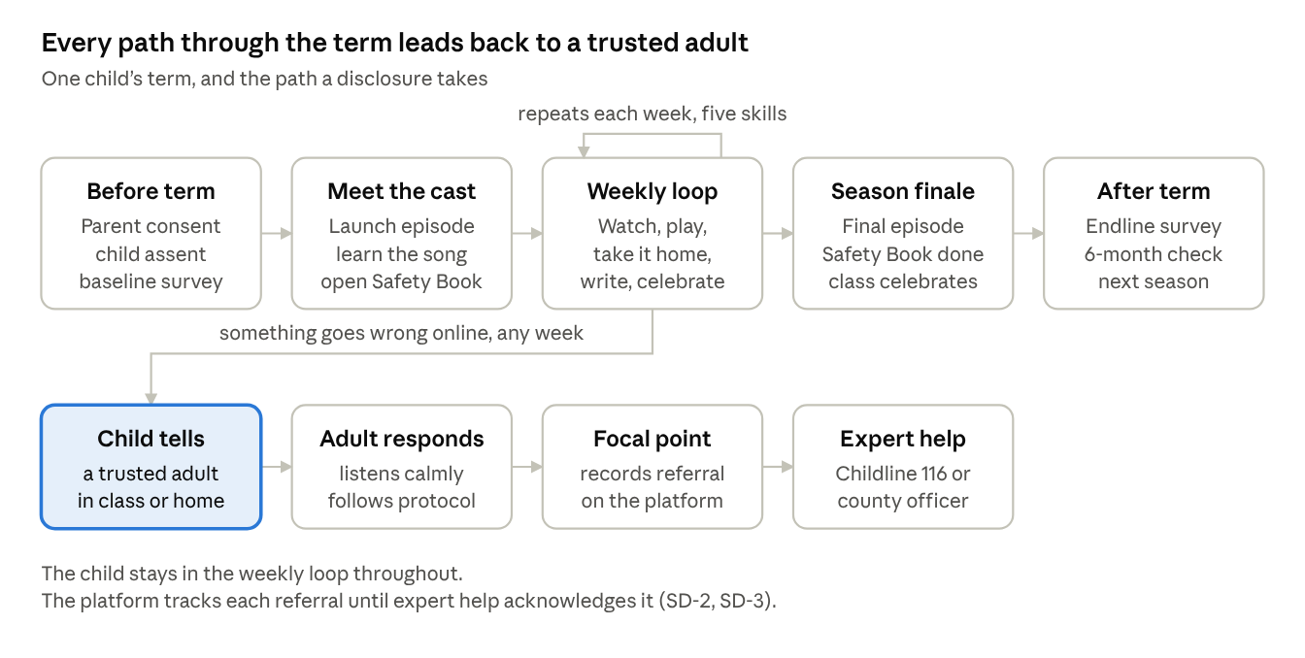
learner journey · one term, 5 stages, 1 disclosure path
The child meets the programme only through adults, broadcast and paper. The platform works behind each stage without the child ever touching it.
Stage | When | What the child does | Who supports | Platform
Before term | Before the first lesson | Takes the baseline survey, read aloud for younger grades | Parent gives consent; child gives assent | EC-1, EC-2, EC-3
Meet the cast | First week | Watches the launch episode, learns the song, opens their Safety Book | Teacher runs the launch lesson; caregiver gets a welcome SMS | ST-2, TK-1, FC-1
Weekly loop | Every week | Watches, plays the class game, does the family challenge, writes a Safety Book page, celebrates the skill | Teacher logs the lesson; caregiver replies DONE | TK-1, TK-3, FC-2, FC-3
Moment of need | Any week | Tells a trusted adult | Adult follows the protocol; focal point refers; Childline 116 or the county children's officer | TK-4, SD-2, SD-3
Season finale | End of term | Watches the final episode, completes the Safety Book, joins a class celebration where nobody is ranked | Teacher; caregivers invited | ST-2, TK-1
After term | End of term, then six months later | Takes the endline and follow-up surveys; starts the next season | Evaluator; teacher | EC-2, EC-5

How the journey grows from 7 to 12
A seven-year-old and a twelve-year-old meet different risks and read at different levels, so the same five skills are taught two ways. The evidence base matches this split: the Be Internet Awesome trial ran in grades 4 to 6, and KiVa serves ages 7 to 11.
 | Ages 7 to 9 (roughly Grades 2 to 4) | Ages 10 to 12 (roughly Grades 5 to 7)
Reading | Picture cards; surveys read aloud | Short text cards; surveys read alone
Scenarios | Sharing photos, videos and games on a family phone | Group chats, gaming chat and messages from people they don't know
Safety Book | Draw, colour and name a trusted adult | Write their own rules and plans
Class play | Whole-class games led by the teacher | Team challenges; older pupils can lead younger ones
Family challenge | The caregiver leads | The child teaches the caregiver
Story | One hero, one problem per episode | Choices with consequences across episodes

Product principles
Every requirement below traces to one of these principles, and each principle traces to evidence on the model page.
- The child is never the user. No child accounts, profiles, chat, tracking or direct messages. Adults operate the platform; children experience it through adults and broadcast.
- Lowest-tech channel first. Every caregiver feature works on a basic phone over SMS or USSD before it is built for WhatsApp or the web.
- Disclosure is the core flow. Every surface ends with "tell a trusted adult", and every disclosure has a safe, tracked route to help.
- Make once, deliver everywhere. One approved episode becomes a class lesson, a radio script, a family challenge and a parent clip.
- Measure behaviour, not views. Reach is reported, never counted as success.
- No commercial playbook. No ads, purchases, paid tiers, leaderboards, loss-based streaks, countdown timers or guilt prompts.
- Collect the least data that proves impact. Data is collected only for evaluation, with parental consent and child assent, and is anonymised before analysis.
- Open by default for partners. Content and lesson kits are free to schools and broadcasters, so reach does not depend on one funder.
- Politically neutral. No partisan figure fronts the platform or appears in its content.

Platform architecture
Seven surfaces sit on six shared services, all hosted in Kenya. Three surfaces deliver the programme to teachers and caregivers; four run it behind the scenes.
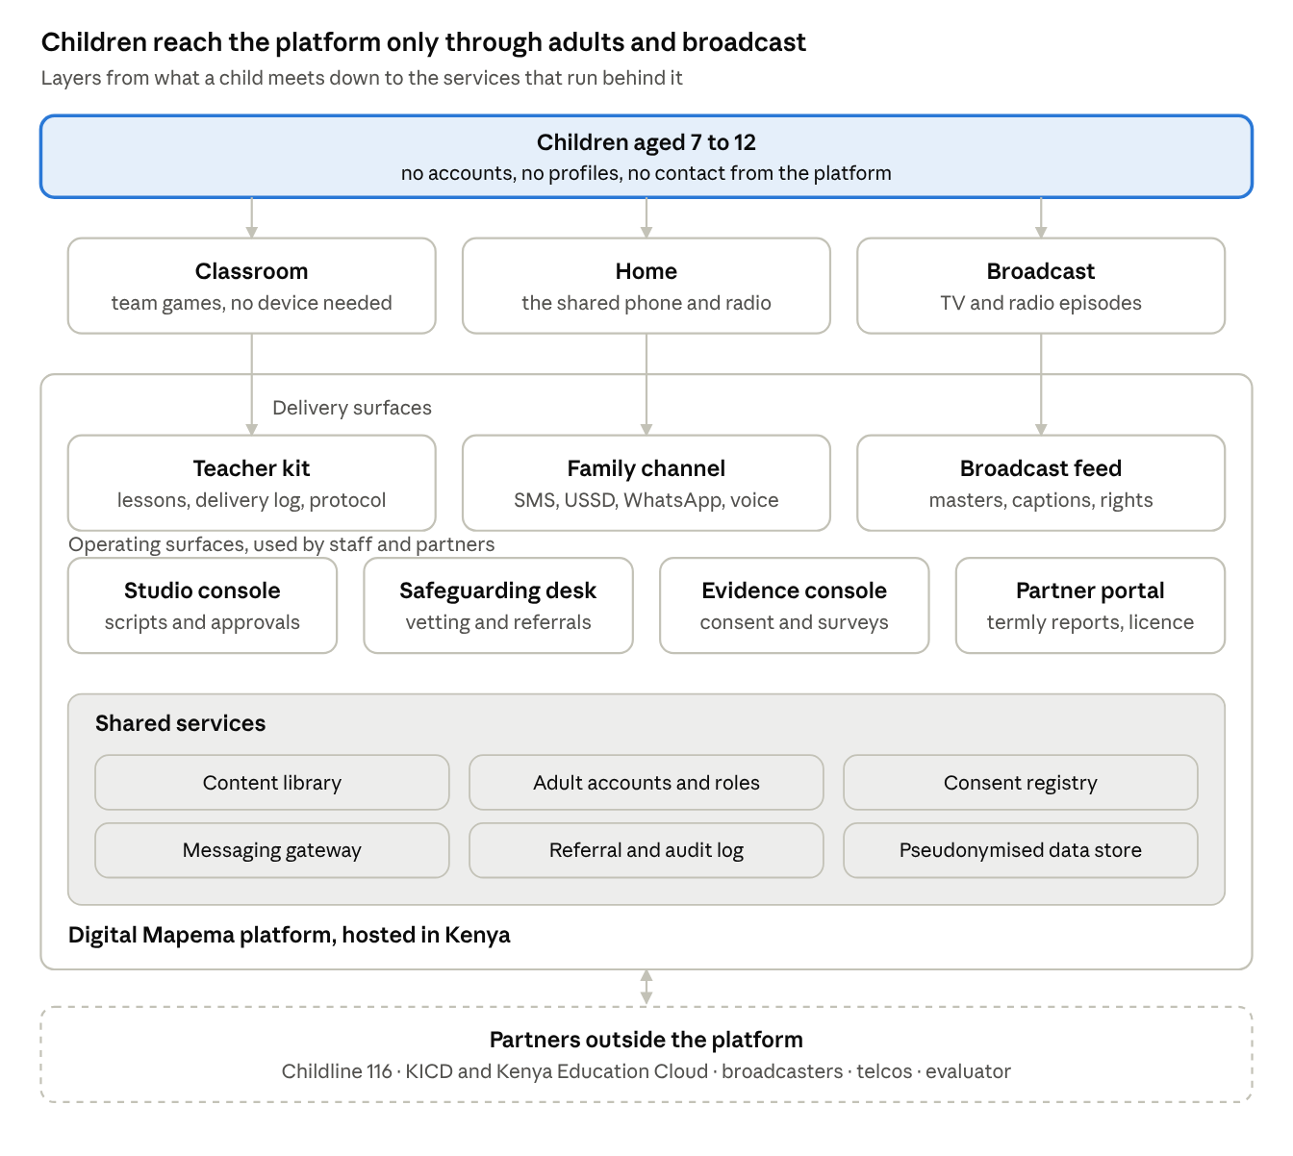
platform architecture · 7 surfaces on 6 shared services
The strategic shift from the current build is the shared services layer. One content library feeds every channel, one consent registry governs all data, and one referral log tracks every disclosure. A partner adds a channel by plugging into these services rather than building its own programme.

Functional requirements
The pilot needs 23 of these 34 requirements. P0 means the pilot cannot run without it, P1 is needed before national scale, and P2 comes later.
ID | Surface | Requirement | Priority
ST-1 | Studio console | Every script moves through draft, educator review, child protection review and approval. Nothing is released without both reviews. | P0 Pilot
ST-2 | Studio console | One approved episode produces four linked assets: class lesson, radio script with response pauses, family challenge and parent clip. | P0 Pilot
ST-3 | Studio console | Every asset exists in English and Kiswahili before release. | P0 Pilot
ST-4 | Studio console | A creator can be assigned to a production only while their vetting is current. | P0 Pilot
ST-5 | Studio console | Each asset carries its licence terms, including the Be Internet Awesome adaptation terms. | P1 Scale
ST-6 | Studio console | Further Kenyan languages, added by county demand. | P2 Later
TK-1 | Teacher kit | A weekly pack: lesson plan, scenario cards, role-play prompts and a Safety Book page, all printable on A4. | P0 Pilot
TK-2 | Teacher kit | Works offline after one sync, on a low-cost Android phone or a school laptop. | P0 Pilot
TK-3 | Teacher kit | The teacher marks a lesson delivered in one tap, or by SMS code when offline. | P0 Pilot
TK-4 | Teacher kit | A disclosure protocol card on every lesson, with one-step referral to the school focal point. | P0 Pilot
TK-5 | Teacher kit | Short training modules that end in a scenario check (outcome T2). | P1 Scale
TK-6 | Teacher kit | Published on the Kenya Education Cloud after KICD approval. | P1 Scale
FC-1 | Family channel | A caregiver opts in by SMS short code or through the school consent form, and the opt-in is recorded. | P0 Pilot
FC-2 | Family channel | One weekly family challenge by single SMS and by USSD menu. | P0 Pilot
FC-3 | Family channel | Reply keywords: DONE logs completion, HELP returns Childline 116 and the school contact, STOP ends all messages. | P0 Pilot
FC-4 | Family channel | At most one reminder a week, and no streaks, penalties or countdowns. | P0 Pilot
FC-5 | Family channel | A WhatsApp version with a creator clip for caregivers who are online. | P1 Scale
FC-6 | Family channel | A voice call or voice note version for caregivers who do not read. | P1 Scale
BF-1 | Broadcast feed | Every episode ends on a card: tell a trusted adult, Childline 116. | P0 Pilot
BF-2 | Broadcast feed | Broadcast-ready masters with captions and Kiswahili audio, delivered with rights metadata to partners such as Akili TV. | P1 Scale
BF-3 | Broadcast feed | Radio packages with scripted pauses for listeners to answer aloud. | P1 Scale
SD-1 | Safeguarding desk | A vetting register holding each adult's Certificate of Good Conduct and safeguarding training date, with expiry alerts. Access locks when either lapses. | P0 Pilot
SD-2 | Safeguarding desk | A referral record holds a pseudonymous code, category, time, referral route and status. The child's identity stays with the school and Childline. | P0 Pilot
SD-3 | Safeguarding desk | A referral not acknowledged within the time set in the safeguarding policy escalates to the safeguarding lead. | P0 Pilot
SD-4 | Safeguarding desk | Any report about an adult on the platform suspends their access until it is reviewed. | P0 Pilot
SD-5 | Safeguarding desk | Every view of a referral record is logged and auditable. | P0 Pilot
EC-1 | Evidence console | A consent registry records parental consent and child assent per pupil before any data is collected. | P0 Pilot
EC-2 | Evidence console | Survey instruments for tablet or paper, with a read-aloud mode for younger grades. | P0 Pilot
EC-3 | Evidence console | Records each school's trial arm, start now or waiting list, as assigned by the evaluator. | P0 Pilot
EC-4 | Evidence console | A dosage view built from lesson logs and DONE replies. | P0 Pilot
EC-5 | Evidence console | Anonymised exports to the evaluator; no names leave the consent registry. | P0 Pilot
PP-1 | Partner portal | A termly aggregate report of reach at full dosage and outcomes, never child-level data. | P1 Scale
PP-2 | Partner portal | A report template showing telcos and platforms how their support meets their Child Online Protection duties. | P1 Scale
PP-3 | Partner portal | A free content licence and download for schools and broadcasters. | P1 Scale

Non-functional requirements
Safeguarding and data protection carry the same weight as features: a pilot that fails either one stops.
Area | Requirement | Basis
Registration | IDI, or the spun-out entity, registers with the Office of the Data Protection Commissioner before any data is collected. | Data Protection Act 2019, section 18
Impact assessment | A data protection impact assessment is completed and filed before the pilot. The Act requires reports 60 days before processing, so this sits on the critical path. | Section 31
Children's data | Parental consent for every child whose data is processed, processing in the child's best interests, and a recorded consent method. | Section 33
Data minimisation | No child names, photos, voices, locations or device identifiers in the platform. Evaluation data is pseudonymised at capture. | Principle 7
Data residency | All personal data is hosted in Kenya. This also removes any question under the strategic-interest localisation rule. | Data Protection (General) Regulations 2021
Access control | Role-based access; referral records visible only to the focal point concerned and the safeguarding lead; every access logged. | SD-5
Retention | Evaluation data deleted or fully anonymised at a date set in the impact assessment. | Section 31
Offline | Teacher kit usable with no connection after one sync; caregiver features usable on a basic phone. | Disrupting Harm Kenya access data
Cost to families | SMS and USSD free to the caregiver, zero-rated or reverse-billed through telco partners. | Principle 2
Languages | English and Kiswahili at launch for every asset and message. | ST-3
Accessibility | Teacher and partner web surfaces meet WCAG 2.2 AA; voice options for caregivers who do not read. | FC-6
Availability | HELP replies and referral escalation work at all hours; other services can pause for maintenance. | SD-3
Design ethics | No ads, purchases, leaderboards, loss-based streaks, countdowns or guilt prompts anywhere, checked in every release. | Principle 6

Success metrics
The north star is outcome C1 from the model page: the share of children who name a trusted adult and say they would tell them. Every other metric either explains movement in C1 or protects children while it moves. Targets are set with the evaluator after the baseline, so none are stated here.
Metric | Role | Captured by | Model code
Children who would tell a trusted adult | North star | EC-2 survey, baseline, endline, 6 months | C1
Disclosures and referrals per 1,000 pupils | Outcome; a rise is read as a good sign | SD-2 referral records | C2
Scenario knowledge and self-efficacy scores | Leading outcome | EC-2 survey | C3, C4
Caregivers talking monthly with their child | Outcome | Caregiver survey; FC-3 replies | P1
Planned lessons delivered in full | Dosage | TK-3 delivery log | T1
Households completing the weekly family challenge | Dosage | FC-3 DONE replies; Safety Book check | S5
Referrals acknowledged within the policy time | Safety | SD-3 escalation log | New
Adults with current vetting | Safety; must be 100% | SD-1 register | S1
Assessed children with consent and assent | Safety; must be 100% | EC-1 registry | S2
Days from draft script to approved asset | Operations | ST-1 workflow | New
The platform never reports time spent, sessions or daily actives as success. Those measures reward the design patterns Principle 6 forbids.

Design approach
We design around one behaviour, a child telling a trusted adult, and treat everything else on the platform as the system that makes that behaviour likely and safe. Three lenses shape the work.
Life-centred design. The unit of design is the child's whole world: home, classroom, the shared phone, the radio, the school focal point and Childline. A feature that works on screen but breaks a teacher's week or a caregiver's airtime budget has failed.
Behavioural design. Disclosure needs three things at once: the child must know what to say (capability), have an adult who will listen and know what to do (opportunity), and believe telling will help (motivation). This is the COM-B model. Each episode, class game and family challenge is checked against all three.
Design with children, not for them. Children aged 7 to 12 name the skills, voice the characters, write the song and play-test every game before production money is spent.

How the work runs
Each phase ends in a named output that a decision-maker signs off.
Phase | What we do | Output that closes it
1. Permissions | NACOSTI research licence and ethics committee approval; child protection protocol for all sessions | Approved research protocol
2. Understand | Home and school visits in one urban, one peri-urban and one rural county; device diaries with caregivers; teacher interviews | Insight report and service blueprint for each channel
3. Co-design | Sessions with children on characters, the five skill names and the song; sessions with teachers on the weekly loop | Character bible and skill language in English and Kiswahili
4. Prototype and play-test | Paper prototypes of the class game; a manual test of the SMS family challenge run by staff; teacher kit usability tests | Tested prototypes of every P0 surface
5. Build | Production of one season; build of the P0 requirements | Pilot-ready release, passed by the safeguarding lead
6. Pilot and learn | One term in programme schools; weekly delivery data; endline | Pilot report and a decision on scale

The design system
One system serves every channel, so a child meets the same characters and words in class, on TV, on radio and at home.
- Characters: a small cast set out in a character bible, co-designed with children. The hero's strongest move every season is telling an adult.
- Language: the five skills and the "tell a trusted adult" line, fixed in English and Kiswahili and used word for word everywhere.
- Sound: the song, the radio pause cue and a short audio sign-off, so radio listeners recognise the programme without pictures.
- Print: A4 templates for lesson cards, the Safety Book and family challenge cards, designed for low-cost black and white printing.
- Digital: one component library for the teacher kit, studio, safeguarding desk and partner portal, built to WCAG 2.2 AA.

Ethics in every session
No session asks a child about their own experiences online. A trained child protection officer attends every session with children, and any disclosure follows the same referral route the platform uses. Parental consent and child assent are recorded before any session.

Release plan
The MVP is the 23 P0 requirements, enough to run one term in pilot schools. The 10 P1 requirements follow only if the pilot passes Gate 3.
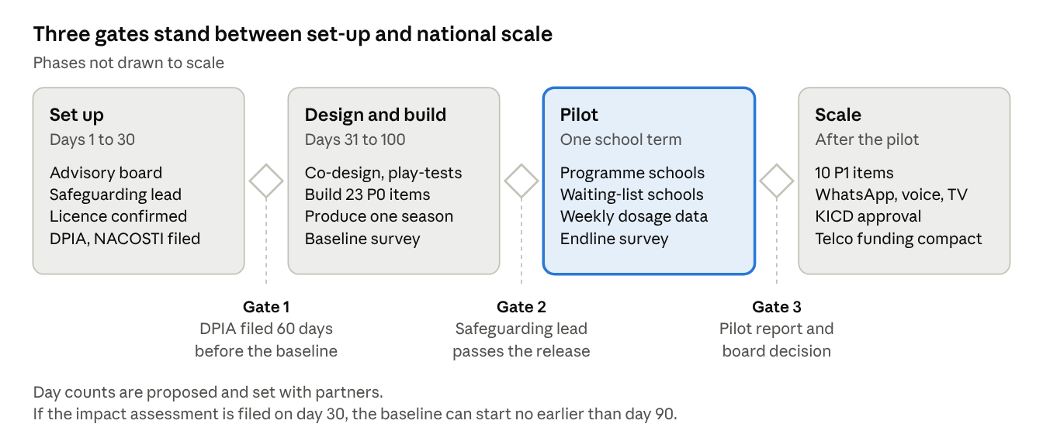
release plan · 4 phases, 3 gates
Release | What ships | Requirements
MVP, for the pilot | Studio workflow, teacher kit, SMS and USSD family challenge, end-of-episode card, safeguarding desk, evidence console | 23 P0 items in Section 6
Scale | WhatsApp and voice for caregivers, broadcast and radio packages, training modules, Kenya Education Cloud, partner portal, licence terms | 10 P1 items
Later | Further Kenyan languages by county demand | ST-6
The impact assessment is the critical path. The Act requires it 60 days before processing, so it starts in the first 30 days or the baseline slips.

Risks, open questions and decisions
The biggest risk is success without capacity: a programme that raises disclosures but has no one ready to answer them.

Decision: build or partner for the family channel
Option | What it means | For | Against
A. Build on an SMS and USSD gateway | Own flows on a Kenyan gateway such as Africa's Talking | Full control of flows and data; data hosted in Kenya | Most build effort; short codes and zero-rating negotiated with each telco
B. Build on RapidPro | UNICEF's open-source messaging platform, which runs U-Report, with a Kenyan gateway underneath | Proven for SMS and WhatsApp flows at scale; aligned with UNICEF partners | Hosting and operations still ours; less design freedom than A
C. Telco-run channel | A telco delivers the family challenge on its own platform as part of its Child Online Protection duties | Free distribution and zero-rating from day one | Data held by the telco; reach tied to one funder; harder to stay neutral
My recommendation is B, with the gateway from A underneath and telcos funding zero-rating, not running the channel. That keeps the data and flows with the programme while using a proven open platform. This is your call.

Risks
Risk | Why it matters | Mitigation
Disclosures rise faster than help can respond | A child who tells and gets no response learns not to tell | Agree referral capacity with Childline Kenya and county children's officers before the pilot; train every focal point
An adult misuses access to the programme | The programme would create the harm it exists to prevent | No child contact by design; vetting with expiry locks (SD-1); suspension on any report (SD-4)
Impact assessment delays the pilot | The Act requires reports 60 days before processing | Start the assessment in the first 30 days
One term shows no behaviour change | Friendly ATTAC changed confidence but not behaviour after one session | Six-month follow-up built in; the pilot is framed to funders as a learning stage
Teacher workload cuts dosage | Low dosage weakens effects | Zero-preparation lesson packs; delivery logged in one tap (TK-3)
Political capture ahead of the 2027 election | Schools, UNICEF and platforms would step back | Independent board; no partisan figure in governance or content
Be Internet Awesome licence not granted | The curriculum core would need rebuilding | Confirm the licence in the first 30 days; KiVa-style mechanics as fallback

Open questions
- ☐ Who is the data controller during incubation: IDI or the new entity?
- ☐ Which three counties host the pilot?
- ☐ What is KICD's approval route and timeline for supplementary content?
- ☐ What referral capacity does Childline Kenya have for a pilot of this size?
- ☐ Settled: the founder owns Digital Mapema and builds on the existing digitalmapema.com platform.

Sources
The full evidence base, including every exemplar platform, is on the Digital Mapema model page. Sources used directly in this document:
- Disrupting Harm in Kenya, full report (UNICEF Innocenti, 2022)
- UNICEF, Through Children's Eyes (Capital FM, September 2026)
- CA Child Online Protection guidelines in force
- Kenya Data Protection Act 2019, sections 18, 31 and 33
- Data Protection (General) Regulations 2021, localisation summary (Oraro)
- Be Internet Awesome cluster randomised trial
- Friendly ATTAC cluster randomised trial
- Sailer and Homner, gamification meta-analysis
- Radesky et al., manipulative design in children's apps
- UK Children's Code standards
- Akili TV
- Childline Kenya 116

